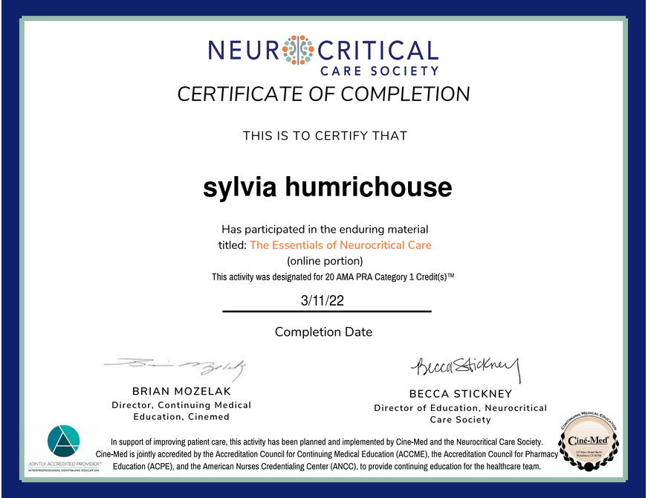
Print Certificate
Congratulations on finishing the online portion of the Essentials of Neurocritical Care course! Please present the certificate below upon arrival at the in-person workshops (or ask a staff member to confirm your completion of the exams).
Upon completion of the in-person workshops, and verification of online exam completion, you will be given your Essentials of Neurocritical Care Certificate of Completion and Certification Card.
If you have any questions, please email education@neurocriticalcare.org.

